35.Design DFA using simulator to accept strings in which a’s always appear tripled over input {a,b}

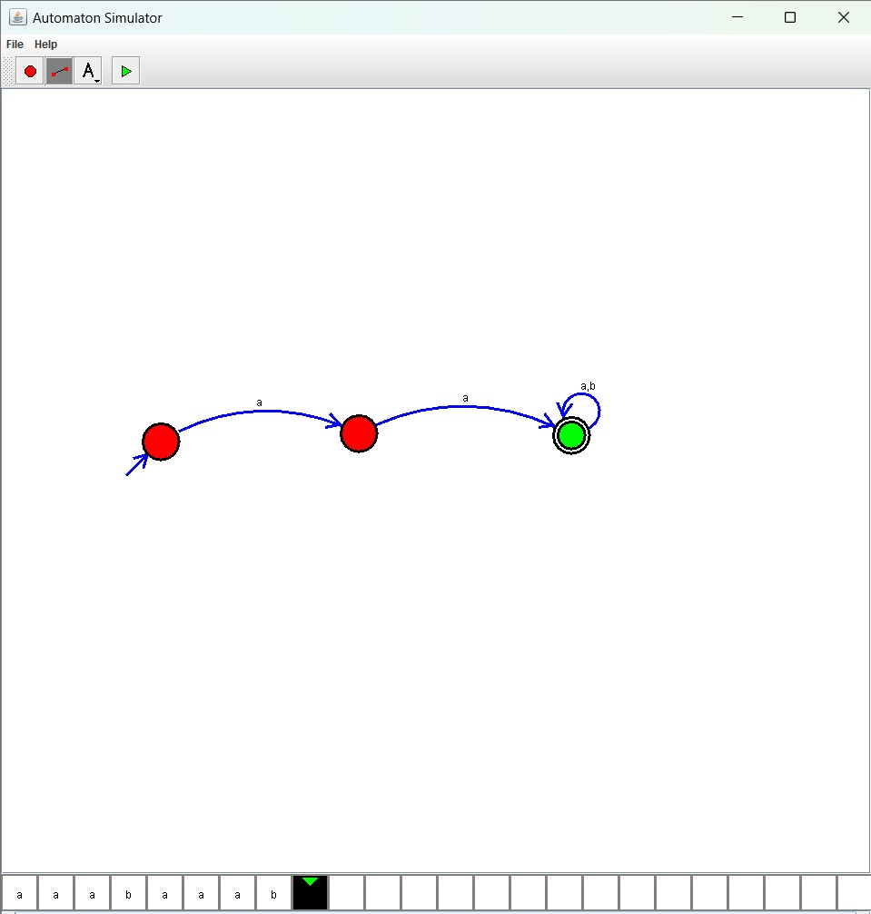

Result :

The simulator accepted strings in which a’s always appear tripled over input {a,b} by using the above DFA diagram